**Muhammad Umar Ahmadzai**

**01/21/2018**

**Extra Assignment: Birthday Game**

**Problem Statement:**

This program is going to provide the user with number of sets, and each asking the user if he or she can find his age in those sets. If yes, user will press 1 and otherwise user will press 0. There are total of five sets, so user will be asked five time. In result, user will be provided with his age as result.

**Input/Output Description:**

First, we are going to ask the user if he or she could find his age in five sets presented.

cout << "Press 1, if you age is mentioned in the set otherwise if not, press 0" << endl<< endl;

cout << "1, 3, 5, 7, 9, 11, 13, 15, 17, 19, 21, 23, 25, 27, 29, 31" << endl<< endl;

User is going to press 1 if yes, otherwise 0.

cin >>set1;

Same goes for 4 four other sets.

This will give the final result of what is the actual age of the user.

cout << endl << "Your age is " << ageguess << "." << endl;

**Algorithm Development:**

Basically, we will have six variables, set 1, set 2, set 3, set 4, set 5 and ageguess. First five variables will have the user to input 0 or 1 for each set. Age guess variable will do the calculation to find the age of the user.

**Program Listing:**

#include <iostream>

using namespace std;

int main()

{

int set1, set2, set3, set4, set5, set6, ageguess;

cout << "Press 1, if your age is mentioned in the set otherwise if not, press 0" << endl<< endl;

cout << "1, 3, 5, 7, 9, 11, 13, 15, 17, 19, 21, 23, 25, 27, 29, 31" << endl<< endl;

cin >>set1;

cout << "Press 1, if your age is mentioned in the set otherwise if not, press 0" << endl<< endl;

cout << "2, 3, 6, 7, 10, 11, 14, 15, 18, 19, 22, 23, 26, 27, 30, 31" << endl<< endl;

cin >> set2;

cout << "Press 1, if your age is mentioned in the set otherwise if not, press 0" << endl<< endl;

cout << "4, 5, 6, 7, 12, 13, 14, 15, 20, 21, 22, 23, 28, 29, 30, 31" << endl<< endl;

cin >> set3;

cout << "Press 1, if your age is mentioned in the set otherwise if not, press 0" << endl<< endl;

cout << "8, 9, 10, 11, 12, 13, 14, 15, 24, 25, 26, 27, 28, 29, 30, 31" << endl << endl;

cin >> set4;

cout << "Press 1, if your age is mentioned in the set otherwise if not, press 0" << endl<< endl;

cout << "16, 17, 18, 19, 20, 21, 22, 23, 24, 25, 26, 27, 28, 29, 30, 31" << endl<< endl;

cin >> set5;

ageguess= (set1*1)+(set2*2)+(set3*4)+(set4*8)+(set5*16);

cout << endl << "Your age is " << ageguess << "." << endl;

return 0;

}

**Sample test run of the program:**

**Press 1, if your age is mentioned in the set otherwise press 0.**

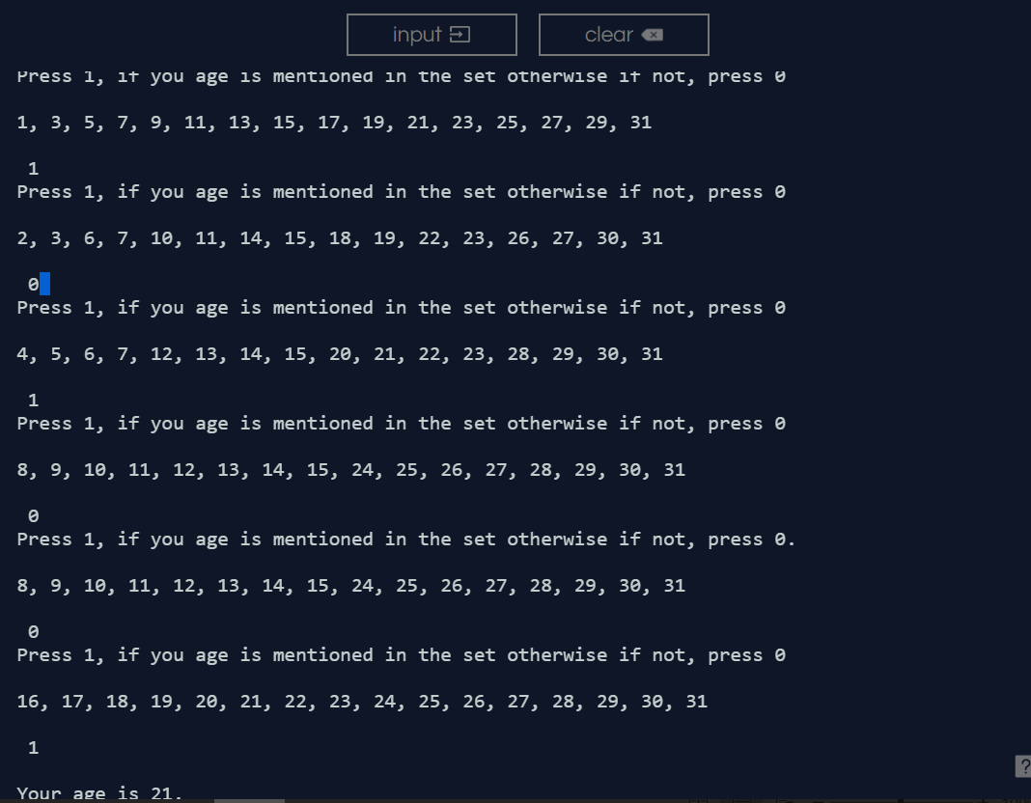

**Observation and Error Handling and general comments:**

Did not faced any errors.

**Conclusion:**

In conclusion, it asks the user five time if their age is mentioned in those sets and will give a final result of their actual age.